 | Sequencing  ‘Small Steps’ | Written calculation and appropriate models an images to support conceptual understanding
Stage 6 | Step 1  Visual representations  (Recovery from Y5) | Children are introduced to ‘per cent’ for the first time and will understand that ‘per cent’ relates to ‘number of parts per hundred’. They will explore this through different representations which show different parts of a hundred. Children will use ‘number of parts per hundred’ alongside the % symbol.  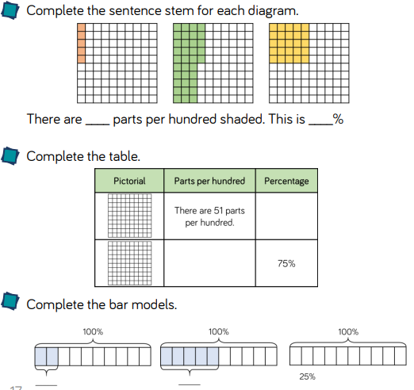
Stage 6 | Step 2  Fluency | It is important that children understand that ‘percent’ means ‘out of 100’. Children will be familiar with converting some common fractions from their work in Year 5 They learn to convert fractions to equivalent fractions where the denominator is 100 in order to find the percentage equivalent.  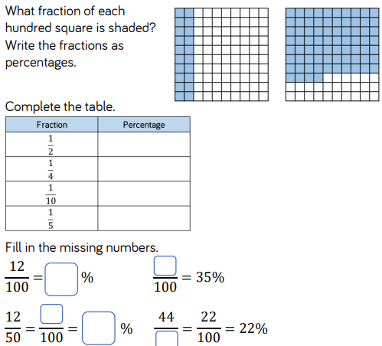
Stage 6 | Step 3  Equivalence | Children use their knowledge of common equivalent fractions and decimals to find the equivalent percentage. A common misconception is that 0.1 is equivalent to 1%. Diagrams may be useful to support understanding the difference between tenths and hundredths and their equivalent percentages  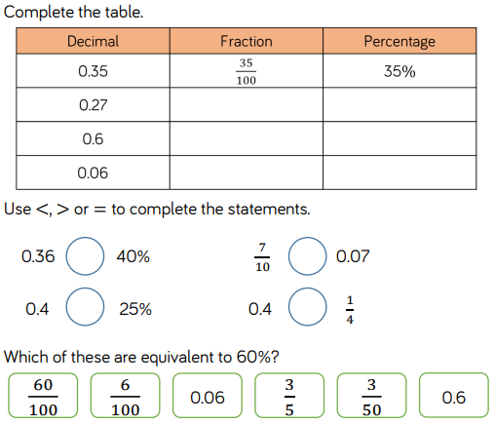
 | Step 4  Ordering FDP | Children convert between fractions, decimals and percentages to enable them to order and compare them. Encourage them to convert each number to the same form so that they can be more easily ordered and compared. Once the children have compared the numbers, they will need to put them back into the original form to answer the question.  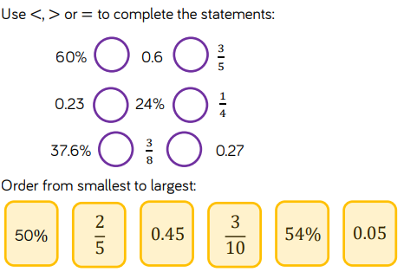
 | Step 5  Percentages of amounts (1) | Children use known fractional equivalences to find percentages of amounts. Bar models and other visual representations may be useful in supporting this e.g. 25% = 1 4 so we divide into 4 equal parts. In this step, we focus on 50%, 25%, 10% and 1% only.  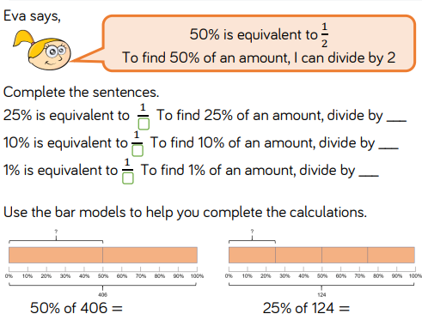
 | Step 6  Percentages of amounts (2) | Children build on the last step by finding multiples of 10% and other known percentages. They explore different methods of finding certain percentages e.g. Finding 20% by dividing by 10 and multiplying by 2 or by dividing by 5. They also explore finding 5% by finding half of 10%. Using these methods, children build up to find percentages such as 35%  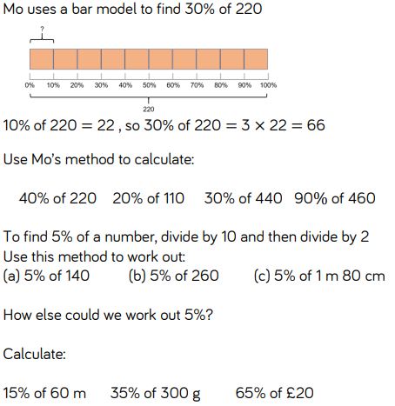
 | Step 7  Missing values | Children use their understanding of percentages to find the missing whole or a missing percentage when the other values are given. They may find it useful to draw a bar model to help them see the relationship between the given percentage or amount and the whole. It is important that children see that there may be more than one way to solve a problem and that some methods are more efficient than others.  

