 | Sequencing  ‘Small Steps’ | Written calculation and appropriate models an images to support conceptual understanding
Stage 5 | Step 1  Visual representations | Children are introduced to ‘per cent’ for the first time and will understand that ‘per cent’ relates to ‘number of parts per hundred’. They will explore this through different representations which show different parts of a hundred. Children will use ‘number of parts per hundred’ alongside the % symbol.  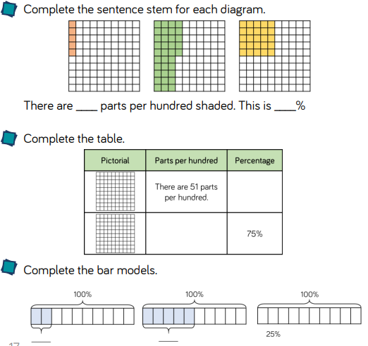
Stage 5 | Step 2  Making connections | Children represent percentages as fractions using the denominator 100 and make the connection to decimals and hundredths. Children will recognise percentages, decimals and fractions are different ways of expressing proportions.  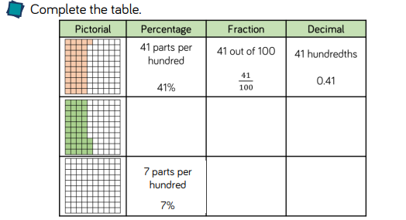
Stage 5 | Step 3  Equivalence | Children recognise simple equivalent fractions and represent them as decimals and percentages. When children are secure with the percentage and decimal equivalents of ½ , ¼ , 1/5 , 2/5 , 4/5 , they then consider denominators of a multiple of 10 or 25 Use bar models and hundred squares to support understanding and show equivalence.  

